Sensor

MQ 135 Sensor Module
Description
This is a MQ 135 Air Quality/Gas Detector Sensor Module For Arduino.

If you are want to make a device that is used to detect Ammonia, Sulphide, and Benzene steam, also sensitive to smoke and other harmful gasses from the desired distance, then this sensor is needed for you.y0u can buy this sensor from Robu.in at a reasonable price.

The MQ 135 Air Quality Detector Sensor Module For Arduino has lower conductivity in clean air. When the target combustible gas exists, the conductivity of the sensor is higher along with the gas concentration rising.

Convert the change of conductivity to the corresponding output signal of gas concentration. The MQ135 gas sensor has a high sensitivity to Ammonia, Sulphide, and Benzene steam, also sensitive to smoke and other harmful gases.

It is at a low cost and suitable for different applications such as harmful gases/smoke detection.

Features :
Sensitivity to Ammonia, Sulphide, and Benzene steam
With signal output instructions
The TTL output signal is a low level
Analog 0 ~ 5 v voltage output, the higher the concentration, the higher the voltage
Color is showing pictures.
Sensitive for benzene, alcohol, smoke
Fast response and recovery
Adjustable sensitivity
Signal output indicator
Output voltage boosts along with the concentration of the measured gases increases.

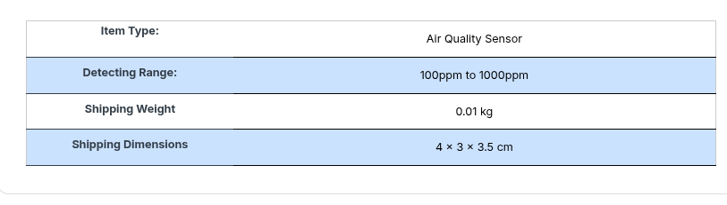

DHT11 Sensor Module
Description
The DHT11 Temperature And Humidity Sensor Module with LED is a small humidity and temperature sensor that you can connect to your Arduino and get readings for temperature and humidity in the environment.

Features:
DHT11 sensor with PCB and LED indicator along with cable; 3 to 5V power and I/O, 4 pins with 0.1″ spacing
The board has pre-built 4.7K or 10K resistor, which you will need to use as a pull-up from the data pin to VCC.
2.5mA max current use during conversion (while requesting data)
Good for 20-80% humidity readings with 5% accuracy
Good for 0-50°C temperature readings ±2°C accuracy.

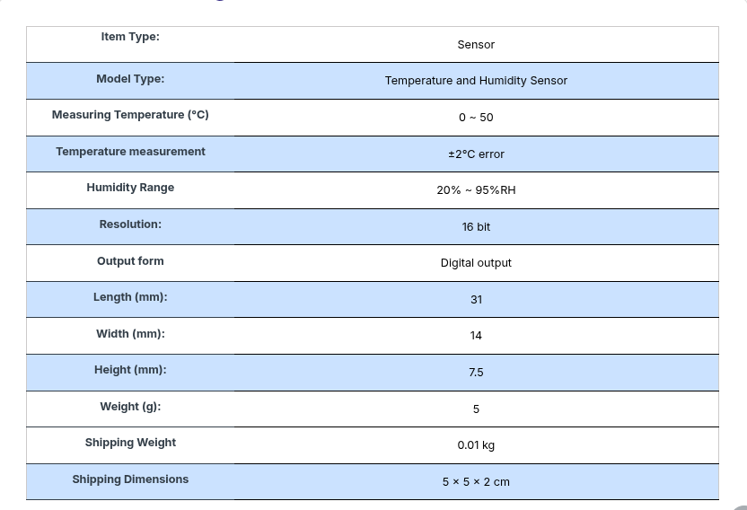

YF-S201 Water Flow Measurement Sensor
Description
This is YF-S201 Water Flow Measurement Sensor with 1-30Liter/min Flow Rate – Black. This sensor sits in line with your water line and contains a pinwheel sensor to measure how much liquid has moved through it. There’s an integrated magnetic hall effect sensor that outputs an electrical pulse with every revolution. The hall effect sensor is sealed from the water pipe and allows the sensor to stay safe and dry.

By counting the pulses from the output of the sensor, you can easily calculate water flow. Each pulse is approximately 2.25 millilitres.

Features :
The simple and compact module.
Easy to Install.
High Sealing Performance.
High-Quality Hall Effect Sensor.

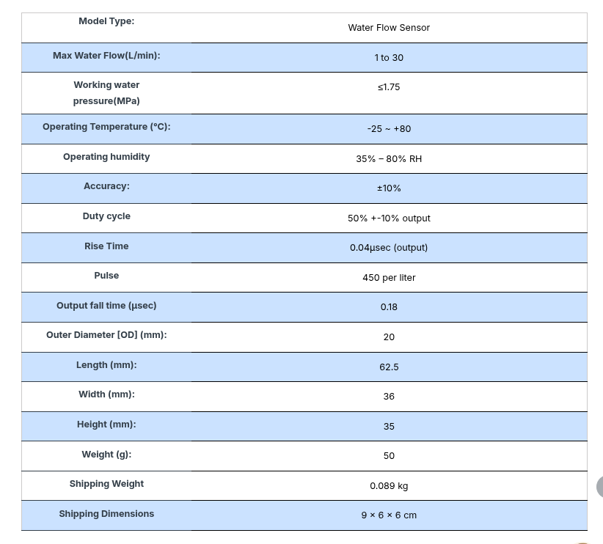

Hx710B Air Pressure (0-40Kpa) Sensor Module
Description

The Hx710B Air Pressure Sensor Module is engineered for applications requiring accurate measurement of low to moderate air pressure. This sensor is ideal for use in weather stations, HVAC systems, barometers, and various industrial applications where precise air pressure data is essential.

Features:
High Accuracy
Analog Output
Straight Header Design
Temperature Compensation

